Query the list of CITY names from **STATION** which have vowels (i.e., a, e, i, o, and u) as both their first and last characters. Your result cannot contain duplicates.

**Input Format**

The **STATION** table is described as follows:

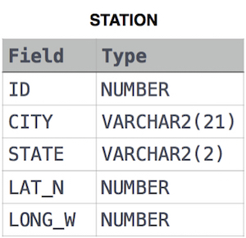

where LAT_N is the northern latitude and LONG_W is the western longitude.

Ans:

select distinct CITY from STATION where

city like 'A%a' or

city like 'A%e' or

city like 'A%i' or

city like 'A%o' or

city like 'A%u' or

city like 'E%a' or

city like 'E%e' or

city like 'E%i' or

city like 'E%o' or

city like 'E%u' or

city like 'I%a' or

city like 'I%e' or

city like 'I%i' or

city like 'I%o' or

city like 'I%u' or

city like 'O%a' or

city like 'O%e' or

city like 'O%i' or

city like 'O%o' or

city like 'O%u' or

city like 'U%a' or

city like 'U%e' or

city like 'U%i' or

city like 'U%o' or

city like 'U%u';